

Chemical Equilibrium Systems



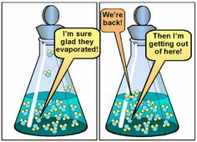

(Elhosiny nd)

(Kimbrough nd)



(Hallatt 2013)

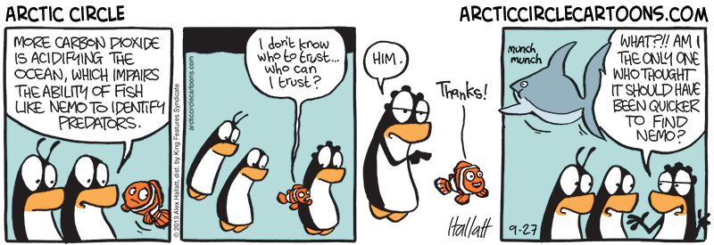

(Hallatt 2013)

|  |  |  |  |
| --- | --- | --- | --- |
| **Week** | **topic** | **unit content** | **assessment** |
| 1 – 4 | Chemical Equilibrium Systems | * collision theory can be used to explain and predict the effects of concentration, temperature, pressure, the presence of catalysts and surface area of reactants on the rates of chemical reactions * chemical systems include physical changes and chemical reactions and may be open (which allow matter and energy to be exchanged with the surroundings) or closed (which allow energy, but not matter, to be exchanged with the surroundings) * observable changes in chemical reactions and physical changes can be described and explained at an atomic and molecular level * over time, in a closed system, reversible physical and chemical changes may reach a state of dynamic equilibrium, with the relative concentrations of products and reactants defining the position of equilibrium * the characteristics of a system in dynamic equilibrium can be described and explained in terms of reaction rates and macroscopic properties * the reversibility of chemical reactions can be explained in terms of the activation energies of the forward and reverse reactions * the effect of changes of temperature on chemical systems initially at equilibrium can be predicted by considering the enthalpy changes for the forward and reverse reactions; this can be represented on energy profile diagrams and explained by the changes in the rates of the forward and reverse reactions * the effects of changes in concentration of solutions and partial pressures of gases on chemical systems initially at equilibrium can be predicted and explained by applying collision theory to the forward and reverse reactions * the effects of changes in temperature, concentration of species in solution, partial pressures of gases, total volume and the addition of a catalyst on equilibrium systems can be predicted using Le Châtelier’s Principle * equilibrium law expressions can be written for homogeneous and heterogeneous systems; the equilibrium constant (K), at any given temperature, indicates the relationship between product and reactant concentrations at equilibrium * the relative amounts of reactants and products (equilibrium position) can be predicted qualitatively using equilibrium constants (Kc) * Levels of carbon dioxide in the atmosphere are rising and have a significant impact on global systems, including surface temperatures. The increasing level of carbon dioxide in the atmosphere causes more carbon dioxide to dissolve in the ocean producing carbonic acid and leading to increased ocean acidity. This is predicted to have a range of negative consequences for marine ecosystems such as coral reefs. Calcification is the process which results in the formation of calcium carbonate structures in marine organisms. Acidification shifts the equilibrium of carbonate chemistry in seawater, decreasing the rate and amount of calcification among a wide range of marine organisms. * The United Nations Kyoto Protocol and the Intergovernmental Panel on Climate Change aim to secure a global commitment to reducing greenhouse gas emissions over the next few decades. | Practical 1  Test 1 |

Collision Theory Review

Collision theory states that in order for a reaction to occur, three criteria must be met:

* Reactant particles must collide
* Reactant particles must collide with a certain minimum energy (activation energy, E­­a)
* Reactant particles must collide with correct orientation

**Exothermic and Endothermic Reactions**

Draw labelled potential energy profile diagrams showing an exothermic reaction and an endothermic reaction.

Factors affecting reaction rates

* **Temperature**

Increasing the temperature increases the average kinetic energy of the reactant particles. This increases the proportion of collisions that have sufficient kinetic energy to meet the activation energy required for a successful collision and so the reaction rate increases. To a much lesser degree, increasing the kinetic energy of the reactant particles increases the speed of the particles which increases the frequency of collisions which increases the reaction rate.

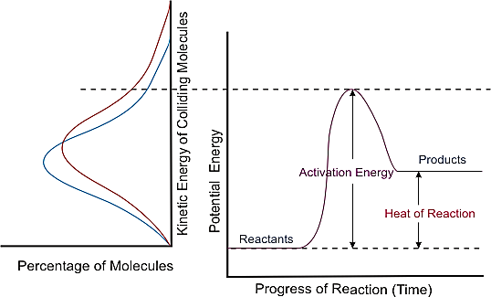

(CDLI 2007)

Draw a labelled diagram to show how temperature affects distribution of collision energies (Essential Chem pg 6)

* **Concentration**

Increasing the concentration (increasing the number of particles in a given space) of one or more of the reactants, increases the frequency of collisions which increases the reaction rate.

* **Pressure**

Increasing the pressure of a gas (by either reducing the volume or adding more of the same gas) decreases the distance between the particles which increases the frequency of collisions which increases the reaction rate.

* **State of subdivision**

Increasing the surface area of one or more of the reactants (e.g. through grinding, atomising (spray), agitation, etc.) exposes more reactant particles to each other at the same time which increases the frequency of collisions which increases the reaction rate.

* **Catalysts**

Catalysts are substances which speed up chemical reactions but remain chemically unchanged by the end of the reaction (i.e. no net consumption of the catalyst occurs).

Catalysts provide an alternate reaction pathway with a lower activation energy. This means a greater proportion of reactant particles will have sufficient kinetic energy to meet the activation energy required for a successful collision to react which increases the reaction rate.

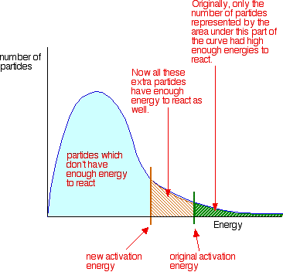

(Clark 2002)

Draw a labelled diagram to show a catalysed and uncatalyzed energy profile diagram. (Essential Che mpg 7)

***Complete Lucarelli Set 1 Review: Energy change and Reaction Rate***

Equilibrium

Many reactions (and processes) are reversible. Reversible reactions tend to have a low activation energy for both the forward and reverse reaction (as opposed to both having a high activation energy or either one of the forward or reverse reactions possessing a high activation energy). As the forward reaction proceeds, the concentration of products builds up which increases the rate of the reverse reaction. The rate of the forward reaction decreases as the concentration of reactants decreases. Once the forward and reverse rates are equal and the concentrations of the products and reactants are constant, a reaction is said to be in equilibrium (NB: the concentrations of the reactants and the products are not necessarily equal). Equilibrium is achieved in closed systems (i.e. systems where energy can enter or leave but matter cannot) and is denoted with the arrow symbol ⇌.

e.g. H2(g) + I2(g) ⇌ 2HI (g)

A system at equilibrium is characterized by:

____________________________________________________________________________________________________________________________________________________________________________________________________________________________________________________________________________________________________________________________________________________________________________________________________________________________________________________________________________________

Physical systems

Vapour Pressure Equilibrium

In a closed system, some of the liquid evaporates to join the vapour phase. At the same time, some vapour particles condense to re-enter the liquid phase. Eventually the rate of condensation will equal the rate of vaporization and equilibrium will be achieved.

e.g. H2O(*l*) ⇌ H2O(g)

The amount of liquid will remain constant as will the vapour pressure above the liquid (so long as no changes are made to the system).

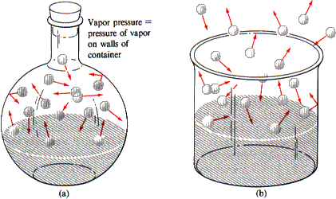

(Rogers, et al. 2000)

What would happen to the system if the temperature of the system were raised?

__________________________________________________________________________________________________________________________________________________________________________________________________________________________________________________________________________________________________________________________________________________________________________________________________________________________________________________________________________________________

Every liquid has a unique equilibrium vapour pressure at a specific temperature. The position of the equilibrium describes the extent to which the liquid is in the vapour phase (how readily the liquid evaporates).

The greater the vapour pressure, the more the equilibrium lies to the right. This means the more readily the liquid evaporates. In general, the weaker the intermolecular forces between the liquid particles, the greater the vapour pressure.

Solution Equilibrium

When a (soluble) solid is placed in a liquid, the solid begins to dissolve. As more solid is added, it continues to dissolve but at the same time, some of the dissolved particles crystallise to re-form. At the point of saturation the rate of dissolution will equal the rate of crystallisation and equilibrium will be achieved. The amount of solid will remain constant as will the concentration of the ions in solution (so long as no changes are made to the system).

e.g. NaC*l*(s) ⇌ Na+(aq) + C*l*‒(aq)

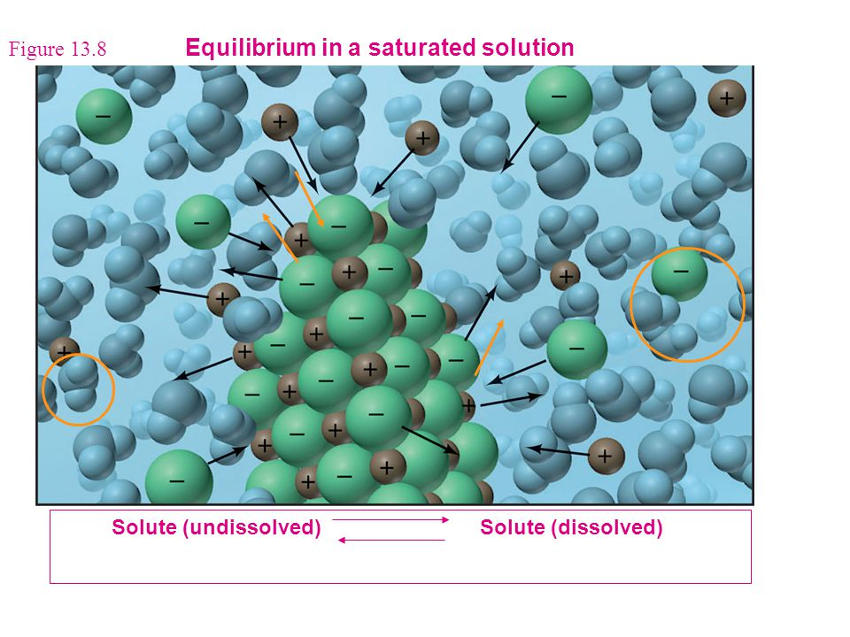

(Marr 2006)

What would happen to the system if the temperature of the system were increased?

____________________________________________________________________________________________________________________________________________________________________________________________________________________________________________________________________________________________________________________________________________________________________________________________________________________________________________________________________________________

Chemical Systems

In chemical systems, the equilibrium in closed systems exists between the reactants and the products.

e.g. 2NO2(g) ⇌ N2O4(g)

brown colourless

In an equilibrium system, the relationship between the concentration of reactants and products has been (experimentally) determined to be a constant at a specific temperature.

The equilibrium constant (or law) expression shows the relationship between the equilibrium concentration of the reactants and products and the equilibrium constant (Kc).

For the general equation:

aA(g) + bB(g) ⇌ cC(g) + dD(g)

it is given as:

No matter what the initial concentrations of the reactants or products, the value of the equilibrium constant will always be the same (provided it is measured under the same temperature conditions).

It is important to note that only aqueous and gaseous species are included in the equilibrium constant expression as the concentrations of solids and liquids are said to be constant from one reaction to the next (concentration is said to be related to density and molar mass of which both remain constant).

Example: Write the equilibrium constant expressions for the following situations:

1. 3O2(g) ⇌ 2O3(g)
2. HF(aq) + H2O(*l*) ⇌ F‒(aq) + H3O+(aq)
3. As4O6(s) + 6C(s) ⇌ As4(g) + 6CO(g)
4. Pb2+(aq) + 2C*l*–(aq) ⇌ PbC*l*2(s)

The equilibrium constant gives an indication of the relative proportions of reactants and products. Large values suggest that the products have a greater concentration than the reactants (i.e. the equilibrium favours the forward reaction/favours the products/lies to the right). Small equilibrium constant values suggest that the reactants have a greater concentration than the products (ie the equilibrium favours the reverse reaction/favours the reactants/lies to the left). Equilibrium constants close to one suggest concentrations of reactants and products are similar.

Example: The Kc values for the ionisation of two weak acids are given below. Which is the stronger acid and why?

CH3COOH(aq) + H2O(*l*) ⇌ CH3COO–(aq) + H3O+(aq)  Kc = 1.82 ×10-5

HCN(aq) + H2O(*l*) ⇌ CN–(aq) + H3O+(aq) Kc = 6.23 ×10-10.

_____________________________________________________________________________________________________________________________________________________________________________________________________________________________________________

It is important to understand that the equilibrium constant gives no information about the rate of a reaction.

Le Châtelier’s Principle

Le Châtelier’s Principle allows us to predict **(but not explain)** the effect changes on a system at equilibrium will have. It can be stated as:

“If a system at equilibrium is subjected to a change in conditions, the system will re-establish equilibrium in such a way as to partially counteract the imposed change.”

Changes to a system at equilibrium can include changing the:

* concentration of any one aqueous or gaseous species (by adding or removing it from the system)
* concentration of multiple species in solution (by adding or removing the solvent (usually water))
* total pressure of a gaseous system (by increasing or decreasing the volume of the system)
* temperature of the system (by adding or removing heat from the system)

It is very important to remember that Le Châtelier’s principle **only predicts** how a system will react to changes imposed. The principles of reaction rates and collision theory are used to **explain** the changes.

**Changes to systems at equilibrium can be graphically presented in two ways:**

* Concentration-time graph – plots concentration of all gaseous and/or aqueous species as a function of time.
* Reaction rate-time graph – plots the rate of the forward and reverse reactions as a function of time.

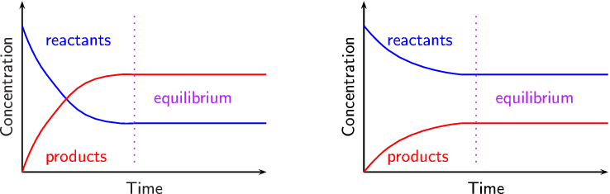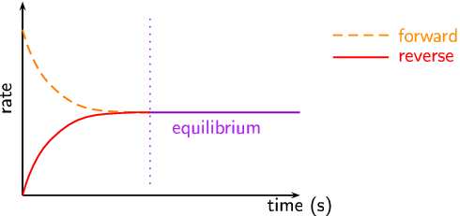

(Siyavula nd)

**Concentration Changes**

When the concentration of a particular species is changed (by addition or removal), Le Châtelier’s principle predicts how the system will react. If a species’ concentration is decreased, the equilibrium will shift to partially counteract this change by favouring the reaction that increases the concentration of that particular species. If a species’ concentration is increased, the equilibrium will shift to partially counteract this change and favour the reaction that decreases the concentration of that particular species.

Using the example: Cr2O72-(aq) + OH‒(aq) ⇌ 2CrO42-(aq) + H2O(*l*)

orange yellow

Draw a labelled **concentration-time graph** that shows the first equilibrium being achieved when a solution of potassium dichromate is added to a solution of sodium hydroxide.

Draw a labelled **reaction rate-time graph** that shows the first equilibrium being achieved when a solution of potassium dichromate is added to a solution of sodium hydroxide

What would you observe as equilibrium is achieved?

_____________________________________________________________________________

Predict the change in equilibrium if more potassium dichromate is added to the system at equilibrium.

__________________________________________________________________________________________________________________________________________________________________________________________________________________________________________

What would you observe?

____________________________________________________________________________________________________________________________________________________________

Explain the change in equilibrium.

__________________________________________________________________________________________________________________________________________________________________________________________________________________________________________

__________________________________________________________________________________________________________________________________________________________________________________________________________________________________________

On the previous concentration-time and reaction rate-time axes continue the diagrams so that they show the second equilibrium being achieved when extra potassium dichromate is added to the solution at equilibrium.

After the second equilibrium is established in both graphs, draw what would happen if a small amount of concentrated hydrochloric acid was added to the system at initial equilibrium.

Draw the final situation given above on two new sets of concentration-time and reaction rate-time axes if you were beginning at equilibrium.

**Changing concentration by adding or evaporating the solvent**

The concentration of all species in a system can be manipulated by adding or evaporating the solvent (usually water).

When adding water to the entire system, this has the effect of reducing the concentration of all species. This will increase the distance between all the particles which reduces the frequency of collisions and so reduces the rate of both the forward and reverse reactions. The rate of the reaction that uses up the most particles will be decreased the most (based on relative proportions) and so the reaction that produces more particles will occur at a greater rate (be favoured) until equilibrium is re-established.

When removing water from the entire system (i.e. evaporation), this has the effect of increasing the concentration of all species. This will decrease the distance between all the particles which increases the frequency of collisions and so increases the rate of both the forward and reverse reactions. The rate of the reaction that uses up the most particles will be increased the most (based on relative proportions) and so the reaction that produces less particles will occur at a greater rate (be favoured) until equilibrium is re-established.

e.g. Co(H2O)62+(aq) + 4C*l*‒(aq) ⇌ CoC*l*42-(aq) + 6H2O(*l*).

pink blue

Predict the change in equilibrium if more water is added to the system above.

________________________________________________________________________________________________________________________________________________________________________________________________________________________________________________________________________________________________________________________

What would you observe?

____________________________________________________________________________________________________________________________________________________________

Explain the change in equilibrium.

__________________________________________________________________________________________________________________________________________________________________________________________________________________________________________

__________________________________________________________________________________________________________________________________________________________________________________________________________________________________________

**Total Pressure Changes (ie Changes in Volume of Gaseous Systems)**

When the total pressure of a system is changed (by manipulating volume), Le Châtelier’s principle predicts how the system will react. If the volume of the system is increased, this decreases the total pressure. The equilibrium will shift to try to increase the total pressure again which means it will favour the side with the greater number of particles (increasing the total number of moles of gaseous particles in the system). If both sides of the equilibrium have the same number of relative particles, there is no change in the position of the equilibrium. Similarly, if an inert gas is added to the system, this will not affect the equilibrium position.

When increasing the volume of the system (i.e. decreasing the pressure of the system), this will increase the distance between all the particles which reduces the frequency of collisions and so reduces the rate of both the forward and reverse reactions. The rate of the reaction that uses up the most particles will be decreased the most (based on relative proportions) and so the reaction that produces more particles will occur at a greater rate (be favoured) until equilibrium is re-established.

When decreasing the volume of the system (i.e. increasing the pressure of the system), this will decrease the distance between all the particles which increases the frequency of collisions and so increases the rate of both the forward and reverse reactions. The rate of the reaction that uses up the most particles will be increased the most (based on relative proportions) and so the reaction that produces less particles will occur at a greater rate (be favoured) until a new equilibrium is established.

Using the example: N2(g) + 3H2(g) ⇌ 2NH3(g)

Draw a labelled concentration-time graph and a labelled reaction rate-time graph that shows the first equilibrium being achieved when gaseous nitrogen and hydrogen are placed in a closed cylinder with a variable volume.

What would you observe as equilibrium is achieved?

__________________________________________________________________________________________________________________________________________________________________________________________________________________________________________

Predict the change in equilibrium if the total volume of the cylinder is increased.

__________________________________________________________________________________________________________________________________________________________________________________________________________________________________________

__________________________________________________________________________________________________________________________________________________________________________________________________________________________________________

Explain the change in equilibrium.

__________________________________________________________________________________________________________________________________________________________________________________________________________________________________________

__________________________________________________________________________________________________________________________________________________________________________________________________________________________________________

____________________________________________________________________________________________________________________________________________________________

On the previous concentration-time and reaction rate-time axes continue the diagrams so that they show the second equilibrium being achieved when the volume of the system at equilibrium is increased. NB: When the volume is increased, the concentration (or partial pressure) of each species will change relative to the others. Similarly, when it returns to equilibrium, although they approach their original concentrations, the final concentrations will never equal (or go below) the initial concentrations at equilibrium.

**Temperature Changes**

When the temperature of a system is changed (by heating or cooling), Le Châtelier’s principle predicts how the system will react (the heat of reaction (ΔH) is needed). If the temperature of the system is increased, the equilibrium will shift to try to decrease the temperature which means it will favour the endothermic reaction (which will use up the excess heat in the system). Conversely, if the temperature of the system is decreased, the equilibrium will shift to try to increase the temperature which means it will favour the exothermic reaction (which will produce heat in the system).

Changes in equilibrium due to temperature changes can be explained by the changes in the rates of the forward and reverse reactions and can be represented on energy profile diagrams.

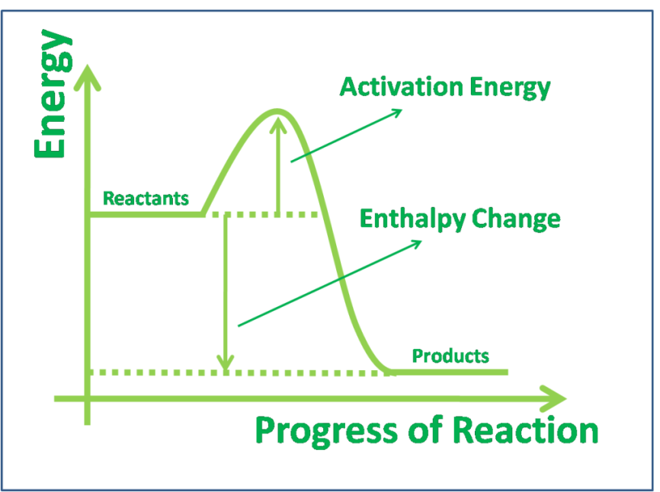For example: 2SO2(g) + O2(g) ⇌ 2SO3(g) ΔH = ‒198 kJ

(Skelly nd)

Adding heat will increase both forward and reverse reactions but it will favour the endothermic reaction (in this case the reverse reaction) to a greater extent. More of the added heat is able to be absorbed by the endothermic reaction, reducing the temperature of the system.

Using the example: I2(g) + H2(g) ⇌ 2HI(g) ΔH = +26 kJ

purple

Draw a labelled concentration-time graph and a labelled reaction rate-time graph that shows the first equilibrium being achieved when gaseous iodine and hydrogen are placed in a closed cylinder.

What would you observe as equilibrium is achieved?

____________________________________________________________________________________________________________________________________________________________

Predict the change in equilibrium if the cylinder is cooled.

__________________________________________________________________________________________________________________________________________________________________________________________________________________________________________

__________________________________________________________________________________________________________________________________________________________________________________________________________________________________________

What would you observe?

___________________________________________________________________________________________________________________________________________________________

Explain the change in equilibrium.

__________________________________________________________________________________________________________________________________________________________________________________________________________________________________________

__________________________________________________________________________________________________________________________________________________________________________________________________________________________________________

____________________________________________________________________________________________________________________________________________________________

On the previous concentration-time and reaction rate-time axes continue the diagrams so that they show the second equilibrium being achieved when the system at equilibrium is cooled.

**Catalyst Changes**

Although adding a catalyst increases the rate at which equilibrium is achieved, as it increases both the forward and reverse reactions, it has no effect on the position of the equilibrium.

**Changes in Conditions and Equilibrium Constants**

Manipulating pressure (total or partial), concentrations and/or the addition of catalysts does not impact the equilibrium constant. Only temperature will change an equilibrium constant. If the forward reaction is endothermic, an increase in temperature will cause an increase in the equilibrium constant. Conversely, an increase in temperature will cause a decrease in the equilibrium constant if the forward reaction is exothermic (and vice versa).

Ocean Equilibria and Atmospheric Carbon Dioxide

The burning of excessive fossil fuels in the recent past has seen atmospheric carbon dioxide levels increase steadily since the 1940s. This is problematic on a number of major fronts but particularly as carbon dioxide is a greenhouse gas and it is slightly soluble in our oceans (which act as carbon sinks, absorbing roughly a third of the Earth’s anthropogenic (human produced) atmospheric carbon dioxide).

With rising global temperatures come rising ocean temperatures. This can have great impact on all manner of marine life. Coral is particularly impacted as a lot of corals rely on a symbiotic relationship with an algae (zooxanthellae) to sustain their life. Sometimes when coral become stressed (as can be the case with rising oceanic temperatures) they expel the algae. If the algae do not return, the coral can become white in colour (bleached) and may eventually die.

The ocean acts as a sink for some of the atmospheric carbon dioxide through the following equilibrium:

Some of the dissolved CO2 can then react with water to produce carbonic acid (H2CO3 – a weak acid) through the following equilibrium:

As carbonic acid is a weak acid, it partially ionises to produce hydrogen (or hydronium) ions according to the equilibrium:

Furthermore, the hydrogencarbonate ion can partially ionise to produce more hydronium ion according to the equilibrium:

The hydronium ion produced can increase the pH of the ocean which can increase the dissolving of solid calcium carbonate (found in calcifying organisms that use calcium carbonate in their shells and skeletons) through the following equilibrium:

Additionally, the free carbonate ions in ocean water that calcifying species use to produce their shells or skeletons can be taken up by the excess hydronium ions in the water according to the equilibrium:

Scientific research on the impacts of ocean acidification on marine organisms and ecosystems is still very much in its infancy. It is undeniable, however that we need to look to ways of reducing the amount of carbon dioxide we are producing through the use and reliance on fossil fuels. Towards this end, the ultimate goal of the United Nations Framework Convention on Climate Change (UNFCCC) and all affiliated bodies is to achieve stabilisation of greenhouse gas concentrations in the atmosphere at a level that would prevent dangerous anthropogenic interference with the climate system.

***Complete Lucarelli Set 2 Chemical Equilibrium***

# Bibliography

CDLI. "Factors Affecting Reaction Rates." *CDLI.* 2007. https://www.cdli.ca/sampleResources/chem3202/unit01_org01_ilo03/b_activity.html (accessed July 8, 2015).

Clark, J. "The Effect of Catalysts on Reaction Rate." *Chemguide.* 2002. http://www.chemguide.co.uk/physical/basicrates/catalyst.html (accessed July 8, 2015).

Elhosiny, E. "Equilibrium." *Pintrest.* nd. https://www.pinterest.com/emanelhosiny/equilibrium/ (accessed December 7, 2015).

"Energy Diagrams." *C&J&S&B's Chemistry Class.* February 1, 2012. http://chemistrywithelevens.blogspot.com.au/2012/02/energy-diagrams.html (accessed December 7, 2015).

Hallatt, A. "By Request: A Cartoon on Ocean Acidification ." *Alex Hallatt's Arctic Circle.* September 27, 2013. http://arcticcirclecartoons.com/2013/09/27/by-request-a-cartoon-on-ocean-acidification/ (accessed December 7, 2015).

Kimbrough, S. "C Equilibrium." *Pintrest.* nd. https://www.pinterest.com/babybananies/c-equilibrium/ (accessed December 7, 2015).

Luetgens, D. "Temperature and Reaction Rate." *Explore, Experiment, Explain: Science An Excellent Adventure.* nd. http://dluetgens.com/temp_and_rxn_rate.html (accessed July 8, 2015).

Marr, K. "Chapter 13 Properties of Solutions." *Slide Player.* 2006. http://slideplayer.com/slide/5244321/ (accessed January 18, 2016).

NA. "Chemistry Cat Meme Generator." *Pics & photos.* 2014. http://funny-pictures.picphotos.net/chemistry-cat-meme-generator-diy-lol510/assets.diylol.com*hfs*6f8*5a9*51e*resized*chemistry-cat-meme-generator-a-covalent-bond-yells-at-an-ionic-bond-didn-t-anybody-ever-teach-you-to-share-3ad3fd.jpg/ (accessed February 26, 2015).

—. "Energy Diagrams." *C&J&S&B's Class Chemistry.* February 1, 2012. http://chemistrywithelevens.blogspot.com.au/2012/02/energy-diagrams.html (accessed July 8, 2015).

—. "Why is an Enzyme Called a Lock and Key Model." *Answers.* nd. http://www.answers.com/Q/Why_is_an_enzyme_called_lock_and_key_model (accessed July 8, 2015).

Rogers, E, I Stovall, L Jones, R Chabay, and E Kean. "Physical Properties of Liquids." *Fundamentals of Chemistry.* 2000. http://www.chem.wisc.edu/deptfiles/genchem/sstutorial/FunChem.htm (accessed January 18, 2016).

Siyavula. "Le Chatelier's Principle." *Everything Maths and Science.* nd. http://www.everythingmaths.co.za/science/grade-12/08-chemical-equilibrium/08-chemical-equilibrium-03.cnxmlplus (accessed January 18, 2016).

Skelly, D. "Chemistry AS Level." *Freezing Blue.* nd. http://www.freezingblue.com/flashcards/print_preview.cgi?cardsetID=260199 (accessed January 18, 2016).